Health Data Analysis

Summary

I was going through a portfolio which made me interested in doing this analysis using the health care data and understanding and the getting the right out come for every question which is been asked in this data analysis.

Tool Used: Azure Data Studio

Questions

What is the **distribution of time**spent in the hospital for patients, are most of them staying less than7 days?

Select time_in_hospital,count(patient_nbr) as cnt

from diabetic_data

group by time_in_hospital

order by time_in_hospital ASC

Which departments perform the most average number of proceduresand surgeries?

select distinct(medical_specialty),avg(num_procedures) as

avg_num_procedures,count(*) as cnt

from diabetic_data

group by medical_specialty

order by avg_num_procedures desc, cnt desc

```Since the nursing director is looking for avg_num_procedures more than 2 and mdical specialities more than 50 patients```

select distinct(medical_specialty),avg(num_procedures) as avg_num_procedures,count(*) as cnt

from diabetic_data

group by medical_specialty

having

avg(num_procedures)>2 and count(*)>50

order by avg_num_procedures desc, cnt desc

Do longer hospital stays **correlate** to more labs procedures being performed?

select distinct(time_in_hospital) as time_in_hospital,avg(num_lab_procedures) as avg_lab_procedures

from diabetic_data

group by time_in_hospital

order by time_in_hospital desc,avg_lab_procedures desc

```So we want to derive procedures between 1-25 as few, 26-55 as average and anything above 55 as many with consideration of departments```

select medical_specialty,num_lab_procedures,

case when num_lab_procedures between 1 and 25 then 'few'

when num_lab_procedures between 26 and 55 then 'Average'

when num_lab_procedures > 55 then 'Many' END,avg(time_in_hospital) as avg_time_in_hospital

from diabetic_data where medical_specialty <>'?'

group by medical_specialty,num_lab_procedures,

case when num_lab_procedures between 1 and 25 then 'few'

when num_lab_procedures between 26 and 55 then 'Average'

when num_lab_procedures > 55 then 'Many' END

```This query is returning the number of lab procedures with avg_time_in_hospital. Now i want to find

avg_number_of_lab_procuders with avg_time_in_hospital```

with cte as (select medical_specialty,num_lab_procedures,

case when num_lab_procedures between 1 and 25 then 'few'

when num_lab_procedures between 26 and 55 then 'Average'

when num_lab_procedures > 55 then 'Many' END as category,avg(time_in_hospital) as avg_time_in_hospital

from diabetic_data where medical_specialty <>'?'

group by medical_specialty,num_lab_procedures,

case when num_lab_procedures between 1 and 25 then 'few'

when num_lab_procedures between 26 and 55 then 'Average'

when num_lab_procedures > 55 then 'Many' END)

Select distinct(avg_time_in_hospital),avg(num_lab_procedures) as avg_num_lab_procedures

from cte

where avg_time_in_hospital>4

group by avg_time_in_hospital

order by avg_time_in_hospital desc

Is there a **racial bias** when it comes to evaluate the amount of lab procedures performed for patients, and does gender of patients has any effect?

How many people belong to **African American**race who are UP for 'Metformin' ?

with cte as (select patient_nbr,race,insulin

from diabetic_data

where race='AfricanAmerican' and insulin=upper('up'))

select distinct(patient_nbr) from cte

When patients are discharged, do they readmit to the hospital in **under 30 days**and are these returning patients coming through emergency room?

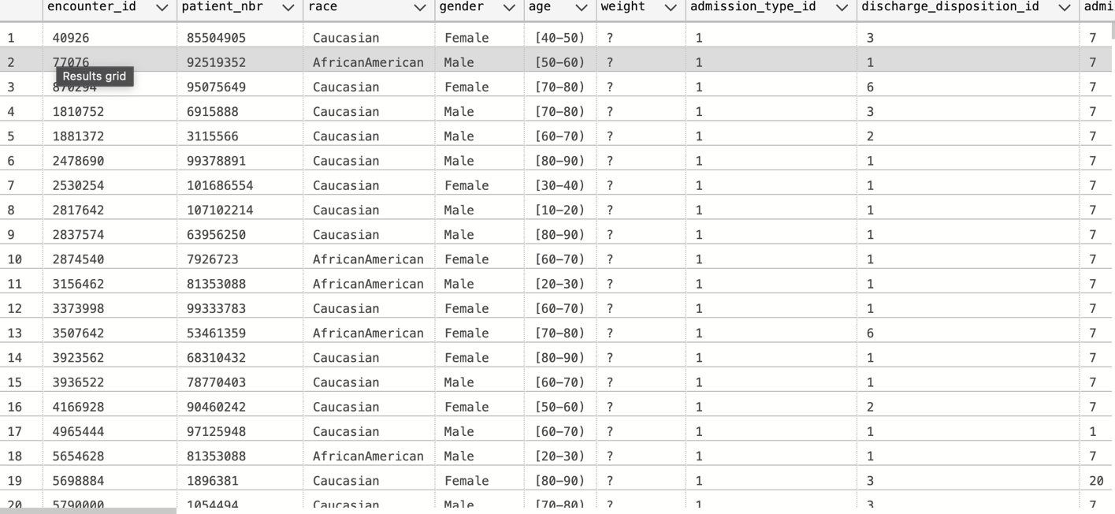

select *

from diabetic_data

where readmitted='<30' and admission_type_id=1

Select *

from diabetic_data

where readmitted='<30' and admission_type_id=1 and time_in_hospital<(select avg(time_in_hospital) from diabetic_data)

A summary of **top 50 patients** with highest number of lab procedures.

select TOP 50 patient_nbr,num_lab_procedures

from diabetic_data

order by num_lab_procedures DESC

